Business Case of App

It is hard to maintain daily time management as a software engineer or other managerial position, we forgot so many things that we need to keep in mind, but what about we maintain our time management not by ourself but by our app, yes this app is representing the meetup in our daily scheduling, by setting up meeting we can keep in track our important meeting related to our work or outside work

The App scenario something like that we can create user for our app and login into our app and we can create meetup by our own, after create our meeting schedule we can see it in our app, so that it is easy to keep in track whether we are doing in our daily schedule meeting.

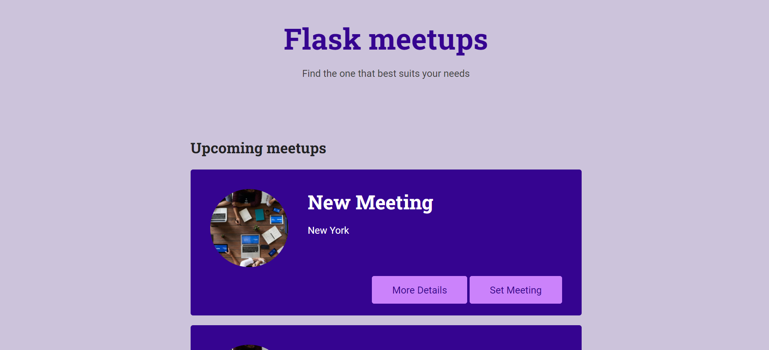

The UI of our app, where upcoming meeting section is here with image and meeting details, if we want to create new meeting just simply using set meeting to setup our new meetings

Reference:

1. <https://www.workfront.com/project-management/life-cycle/initiation/business-case>

!----END----!